**Create an infographic illustrating the Test-Driven Development (TDD) process. Highlight steps like writing tests before code, benefits such as bug reduction, and how it fosters software reliability.**

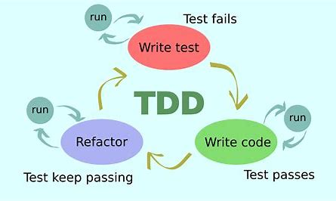

**TDD: TDD is Test Driven Development which follow the agile software development approach. Unlike Traditional way of developing the software i.e., Writing the code then the Testing is done, in TDD Test cases are written first then the coding part is done. This is Modern way of software Development.**

**TDD start with writing the test for each function or feature.**

**Initially test cases are failed because the test cases are written even before the code is written.**

**Advantage:**

* **It meets the customer requirement**
* **Less Debugging is required**
* **Quality software is built**
* **Less error**
* **Unit test provide the continuous feedback**

**The cycle followed in TDD**

1. **Write test Cases – Test cases are written first before the Development therefore it is chance that test case may fail first.**
2. **Write code – After Writing the test case ,the development or coding part is done.**

**Run the code – if it fail then**

1. **Modify code- If after Running the code any error or any bug is found then it is Modified or refractor.**

**Run the code – if it pass process ENDS**

**It faster the software reliability because in this process the test cases are written for every feature or function according to the customer requirement .**

**As the testing is done even before the coding therefore Less debugging is required.**